**PROJECT NAME : FLIPKART**

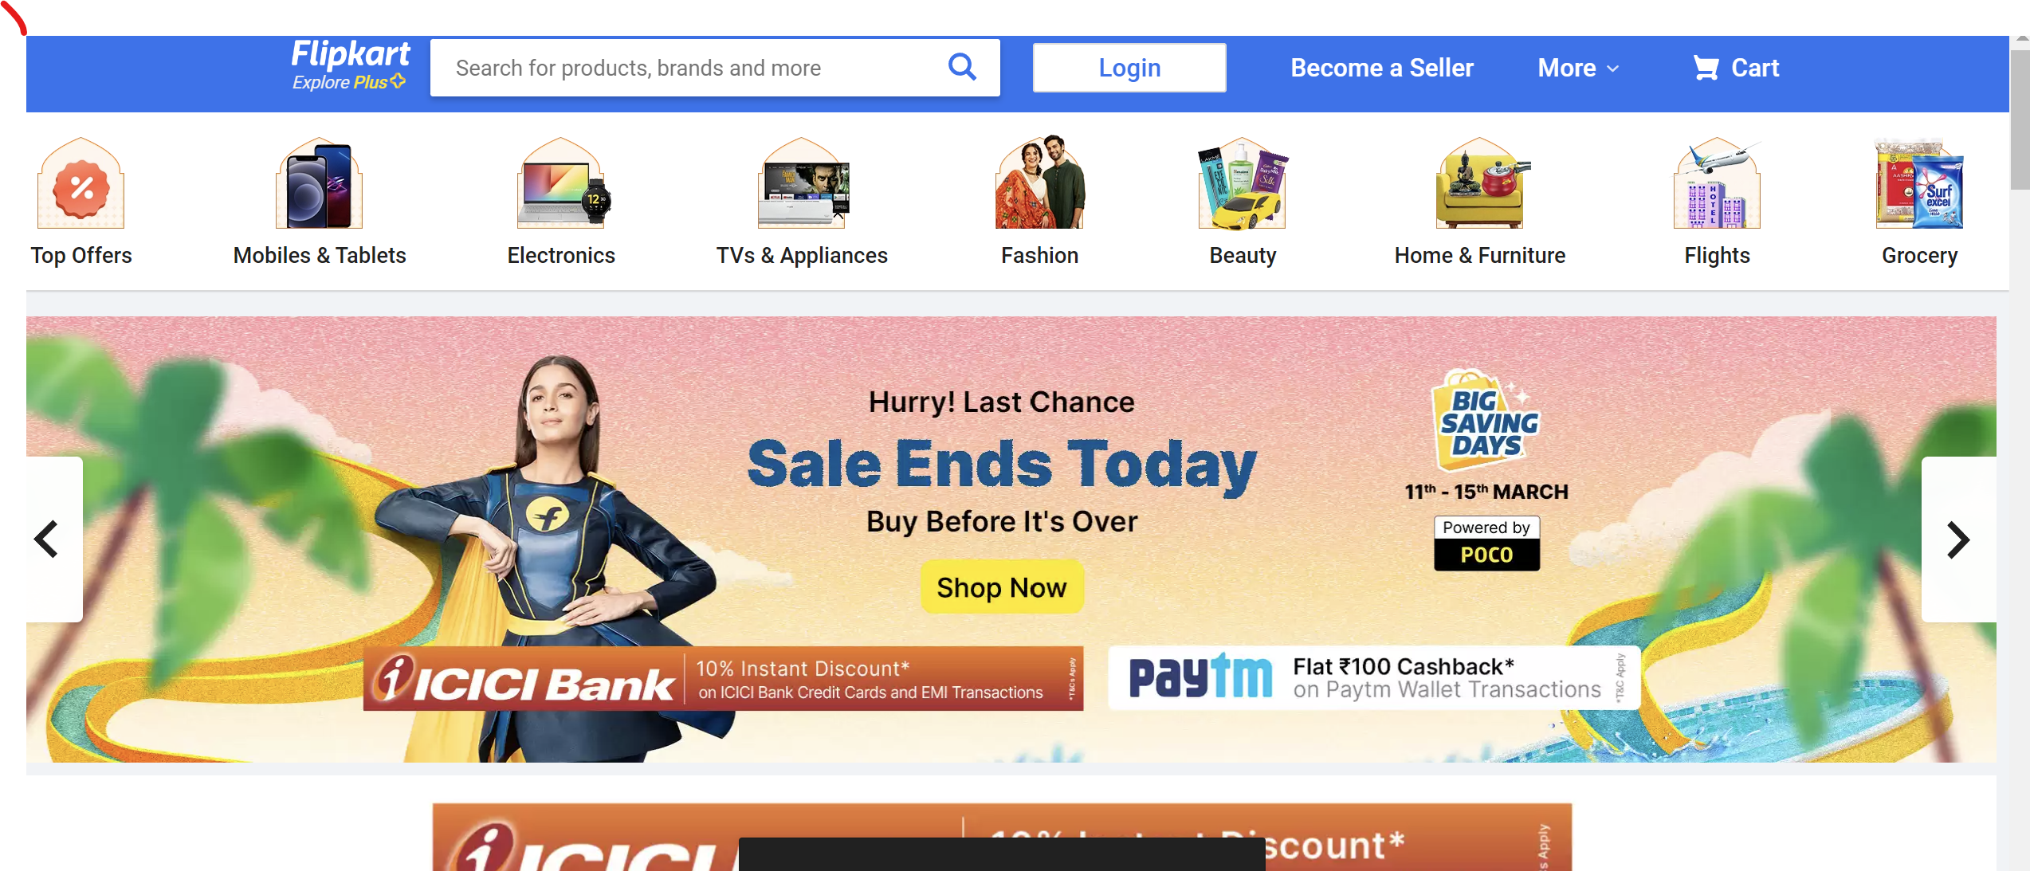

Navigation bar (on top)

* Company name
* Search bar
* Login Button
* Become a seller option
* More
* Cart

Menu bar

A horizontal division below navigation bar where different categories of items are available to see such as top offers, electronics, fashion, groceries etc.

Advertisements and offers and banners section

In this section there are advertisements regarding latest offers and sale weeks with slider images with arrows

Main Page

* Top offers section with image and price description
* On clicking the images different page opens with detail product description and filters
* Featured brands
* Deals with discount

Other lists in Lower Half

* Most searched
* Mobiles
* Cameras
* Laptops
* Clothing
* Footwear
* Groceries
* Best selling products
* About Flipkart
* About items

Footer:

* About
* Help section
* Policy section
* Social media handles
* Mailing address
* Registered address

Payment gateway

Floating icon of cart on top right corner so user can easily go to cart

On reference to site

https://www.flipkart.com/